WEEK 4: MACHINE LEARNING MODEL DEVELOPMENT
Completed Project Report — Python
Student Name: ______________________________
Register Number: ___________________________
Department / Course: _______________________
Institution: _______________________________
Submission Date: ___________________________
Project: Breast Cancer Diagnosis Classification

1. Abstract
This project demonstrates a complete supervised machine-learning workflow in Python. A logistic regression classifier is trained to classify breast-tumor records as benign or malignant using the Wisconsin Diagnostic Breast Cancer dataset available through scikit-learn. The workflow includes data inspection, stratified train/test splitting, missing-value imputation, feature standardization, model fitting, and evaluation with accuracy, precision, recall, F1-score, ROC-AUC, a confusion matrix, and a ROC curve. A majority-class baseline and five-fold cross-validation are also used to provide context. The dataset is publicly available as a teaching dataset, but this educational model is not a clinical diagnostic tool and must not be used to make medical decisions.

2. Introduction and Problem Statement
Machine learning uses patterns in historical data to make predictions about unseen examples. Classification is a supervised-learning task in which each record belongs to a predefined class. In this project, the model predicts whether a breast-tumor record is labeled benign or malignant based on numeric measurements computed from digitized images of fine-needle aspirate samples. The goal is to demonstrate a sound model-development and validation process.

3. Objectives
- Prepare a labeled dataset for supervised classification.
- Choose and justify a suitable baseline algorithm.
- Build a preprocessing and training pipeline using scikit-learn.
- Evaluate predictions on a held-out test set using multiple metrics.
- Create at least two visualizations to communicate performance.
- Discuss errors, overfitting, underfitting, limitations, and possible improvements.

4. Dataset Description
The project uses the Wisconsin Diagnostic Breast Cancer dataset accessed with sklearn.datasets.load_breast_cancer. It contains 569 records and 30 numeric predictor features. The original dataset labels are benign and malignant. For this report, malignant is coded as the positive class (1) and benign as the negative class (0). The data are split into 75% training and 25% test records using stratification and random_state=42.
The exported CSV is supplied with the project package. It contains the predictor columns and a diagnosis column. The built-in dataset is commonly used for educational model evaluation; it does not represent all patient groups or real-world clinical workflows.

5. Data Preparation and Preprocessing
- Loaded the labeled dataset from scikit-learn and inspected its dimensions, features, and target labels.
- Used a stratified train/test split to preserve the class proportions in both subsets.
- Added median imputation to the pipeline so missing numeric values can be handled consistently if present.
- Standardized features with StandardScaler because logistic regression can benefit from predictors on comparable scales.
- Fit preprocessing steps only on the training data through a Pipeline, avoiding leakage from the held-out test set.
- Kept the test set separate until final evaluation to provide an estimate of performance on unseen records.

6. Algorithm Selection
Logistic regression was selected because it is a widely used, interpretable classification baseline, produces class probabilities, trains efficiently, and supports ROC-AUC evaluation. Standardization helps the optimization process when numeric predictors have different scales. Logistic regression assumes a linear relationship between features and log-odds; more complex models may capture nonlinear patterns but can be harder to interpret.

7. Python Code
import pandas as pd
from sklearn.datasets import load_breast_cancer
from sklearn.model_selection import train_test_split
from sklearn.pipeline import Pipeline
from sklearn.impute import SimpleImputer
from sklearn.preprocessing import StandardScaler
from sklearn.linear_model import LogisticRegression
from sklearn.metrics import (
accuracy_score, precision_score, recall_score, f1_score,
roc_auc_score, confusion_matrix, roc_curve
)
data = load_breast_cancer(as_frame=True)
X = data.data
# Make malignant the positive class (1)
y = (data.target == 0).astype(int)
X_train, X_test, y_train, y_test = train_test_split(
X, y, test_size=0.25, random_state=42, stratify=y
)
model = Pipeline([
("imputer", SimpleImputer(strategy="median")),
("scaler", StandardScaler()),
("classifier", LogisticRegression(max_iter=5000, random_state=42))
])
model.fit(X_train, y_train)
y_pred = model.predict(X_test)
y_prob = model.predict_proba(X_test)[:, 1]
print("Accuracy:", accuracy_score(y_test, y_pred))
print("Precision:", precision_score(y_test, y_pred))
print("Recall:", recall_score(y_test, y_pred))
print("F1:", f1_score(y_test, y_pred))
print("ROC-AUC:", roc_auc_score(y_test, y_prob))
print("Confusion matrix:\n", confusion_matrix(y_test, y_pred))

8. Evaluation Metrics
- Accuracy: proportion of all test predictions that are correct.
- Precision: proportion of predicted malignant cases that are truly malignant.
- Recall (sensitivity): proportion of actual malignant cases correctly identified.
- F1-score: harmonic mean of precision and recall.
- ROC-AUC: ability to rank positive cases above negative cases across classification thresholds.
- Confusion matrix: counts of true negatives, false positives, false negatives, and true positives.

9. Test Results
Metric | Test-set score
Accuracy | 0.9650
Precision | 0.9800
Recall | 0.9245
F1-score | 0.9515
ROC-AUC | 0.9962
Test records: 143. Training records: 426.
Majority-class baseline accuracy: 0.6294.
Five-fold cross-validation accuracy on the training subset: 0.9718 ± 0.0160 (mean ± standard deviation).
Interpretation: Accuracy summarizes overall correctness, while recall is particularly important when missing a malignant case could be costly. Precision indicates how many predicted malignant cases are actually malignant. ROC-AUC summarizes ranking performance over multiple thresholds. No single metric should be considered sufficient.

10. Visualizations
Figure 1. Confusion matrix showing correct and incorrect predictions on the held-out test set.
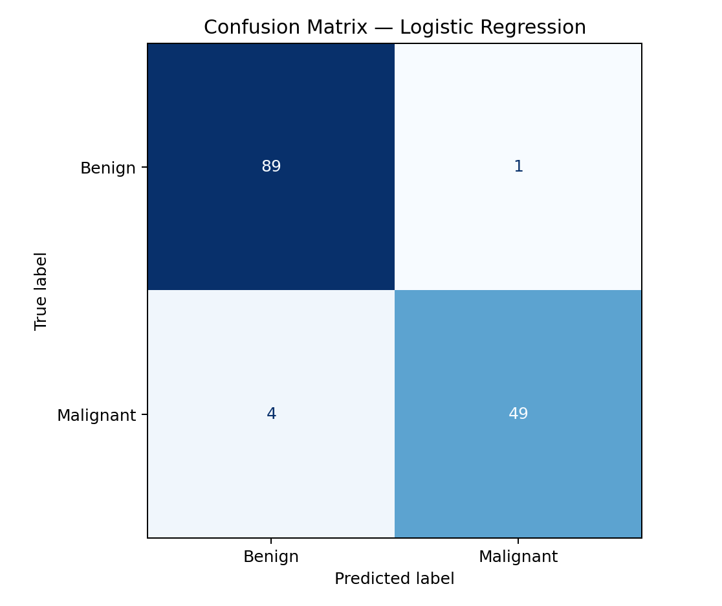
Figure 2. ROC curve showing the trade-off between true-positive and false-positive rates.
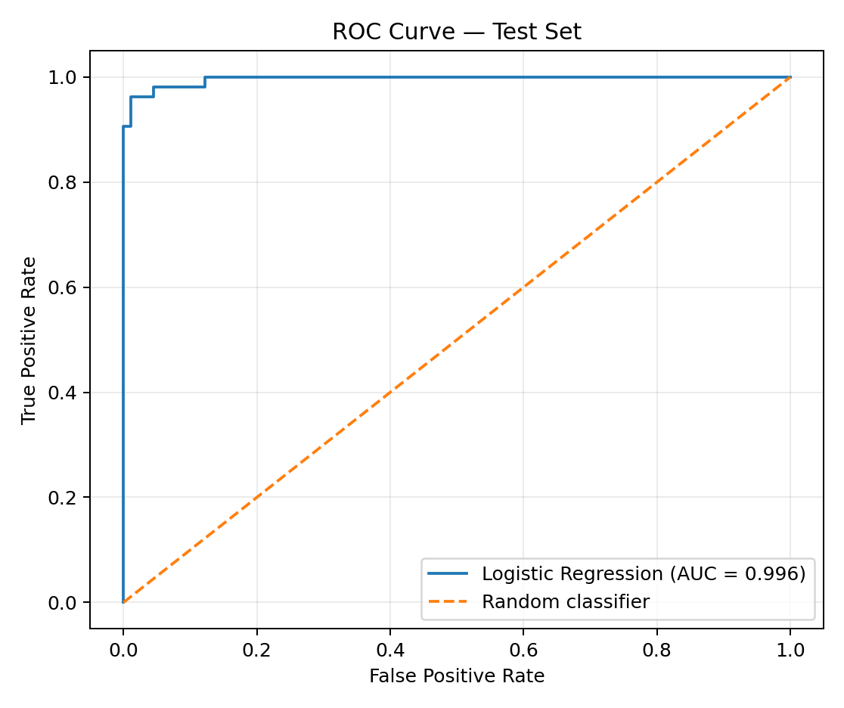
Figure 3. Summary of test-set classification metrics.
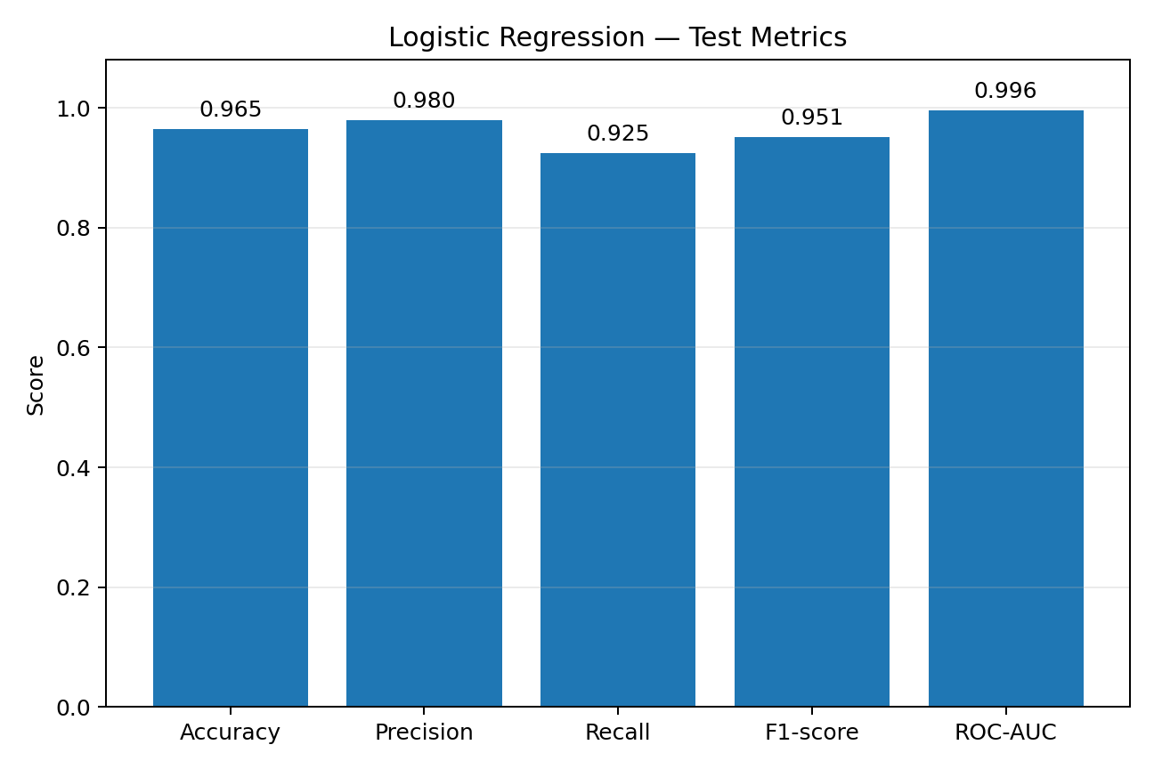

11. Error Analysis and Generalization
The confusion matrix contains TN=89, FP=1, FN=4, and TP=49. False positives are benign records classified as malignant, while false negatives are malignant records classified as benign. In a clinical context, false negatives can be especially consequential; however, this classroom model must not be used clinically. The appropriate decision threshold depends on the intended use, costs of different errors, and expert oversight.

12. Overfitting, Underfitting, and Improvement
- Overfitting: a model performs very well on training data but poorly on unseen data. Check the gap between training and validation performance and use cross-validation.
- Underfitting: a model is too simple to capture the useful signal. Compare with nonlinear models or carefully engineered features.
- Tune regularization strength C with cross-validation, using a pipeline to prevent leakage.
- Compare logistic regression with decision trees, random forests, and support vector machines using the same splits and metrics.
- Use threshold tuning based on the relative cost of false negatives and false positives; select the threshold on validation data, not the test set.
- Assess calibration, class balance, subgroup performance, and confidence intervals for metrics.
- For real-world deployment, evaluate on external data, check data drift, fairness, privacy, and domain-expert requirements.

13. Limitations and Ethical Considerations
This is an educational demonstration using a curated public dataset. Its performance may not transfer to hospitals, equipment, populations, or clinical workflows not represented in the data. The dataset has limited scope and may contain measurement or sampling biases. High test scores do not establish clinical safety. Any real medical model would require rigorous external validation, regulatory review where applicable, privacy protections, and clinician oversight. Predictions must not replace professional medical diagnosis.

14. Conclusion
A logistic regression pipeline was trained and evaluated on a held-out test set. The model achieved accuracy 0.965, precision 0.980, recall 0.925, F1-score 0.951, and ROC-AUC 0.996. The confusion matrix and ROC curve provide additional insight into the types of errors and threshold behavior. The process demonstrates data preparation, algorithm selection, training, validation, and critical evaluation. Results are suitable for educational use only and should not be interpreted as clinical guidance.

15. Reproducibility
Recommended packages: scikit-learn, pandas, numpy, matplotlib, and python-docx for report generation. Install analysis dependencies with: pip install scikit-learn pandas numpy matplotlib. Run the supplied script in Jupyter Notebook, Google Colab, or VS Code. The split seed is fixed at 42 so the train/test partition is reproducible.

16. Suggested 33-Hour Work Plan
Activity | Hours
Topic selection and background research | 3
Dataset exploration and data preparation | 5
Algorithm selection and pipeline design | 4
Model training and validation | 5
Evaluation metrics and error analysis | 5
Visualization and interpretation | 4
Report writing and formatting | 5
Reproducibility checks and final review | 2
Total planned workload: 33 hours. This is a proposed schedule; actual time spent should be recorded honestly.

